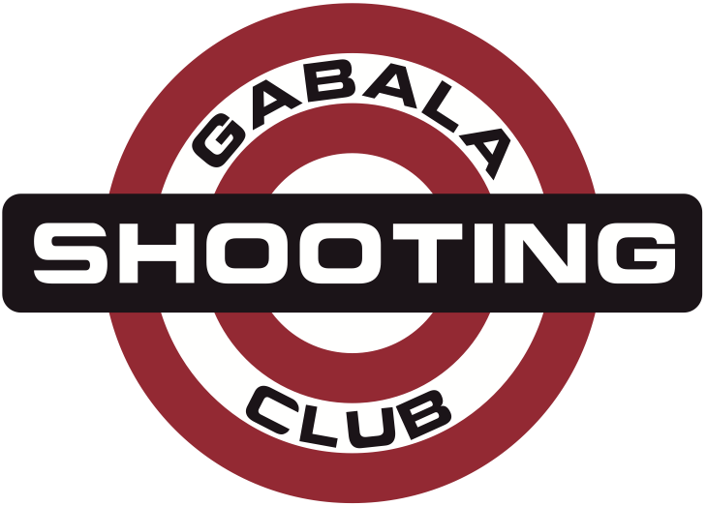
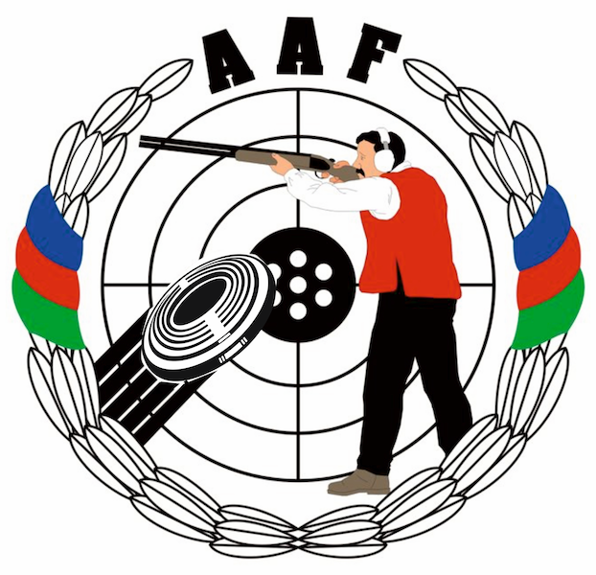
HEYDAR ALIYEV
INTERNATIONAL GRAND PRIX
Gabala, Azerbaijan
14 – 21 August 2014

Please email to Organizing Committee: info@gabala.eu
VISA SUPPORT FORM |  |  |  |  |  | Please return by |  |  | 15 July 2014
name of federation |  |  |  |  |  | nation
contact person |  |  |  |  |  | phone number
e-mail address |  |  |  |  |  | fax number
no | family name |  | first name | date of birth | Passport number |  | issue on |  |  | issue by
Note:

Organizing Committee
Lermontov str. 68
Baku, AZ1066, Azerbaijan
Phone: +994-50-5141515
Phone: +994-55-7537775
E-mail: info@gabala.eu

Date |  | Signature of Team Leader

